Predict the output  
  
 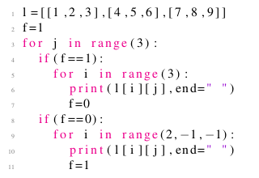

 7 4 1 1 4 7 2 5 8 8 5 2 3 6 9 9 6 3

 1 4 7 2 5 8 3 6 9

 1 4 7 8 5 2 3 6 9

 1 4 7 7 4 1 2 5 8 8 5 2 3 6 9 9 6 3

Yes, the answer is correct.  
Score: 1

Accepted Answers:

*1 4 7 7 4 1 2 5 8 8 5 2 3 6 9 9 6 3*

***1 point***

Predict the output of the calling function func1() for a given square matrix mx of dimension 70 × 70.  
  
 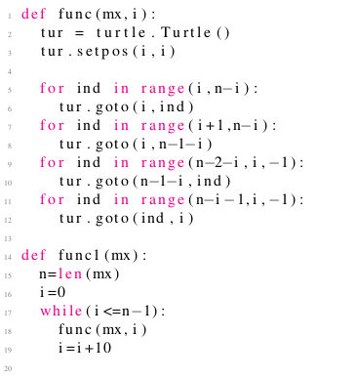

 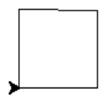

 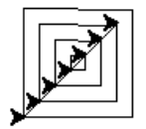

 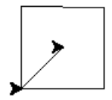

 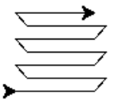

Yes, the answer is correct.  
Score: 1

Accepted Answers:

**

***0 points***

Predict the output of the calling function func() for a given square matrix mx of dimension 70 × 70.  
  
 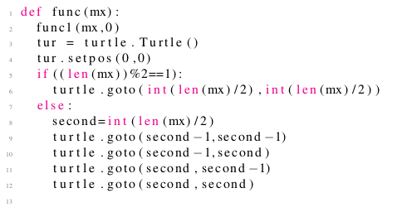

 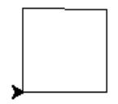

 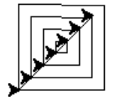

 

 

Yes, the answer is correct.  
Score: 0

Accepted Answers:

**

***1 point***

Which of the following libraries is required to work with Google maps in Python?

 gplot

 googleplot

 gmplot

 none of these

Yes, the answer is correct.  
Score: 1

Accepted Answers:

*gmplot*

***1 point***

Which of the following codes represent a correct version of a board game where the user has to move from block 1 to block 100?  
    The game initialises only when the user gets a 1 or 6 on the dice and ends once he reaches 100 or gets a number which makes  
    him reach beyond 100 (i.e. the player wins if he is at 99 and gets a 4).

  
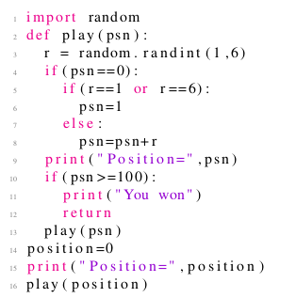

  
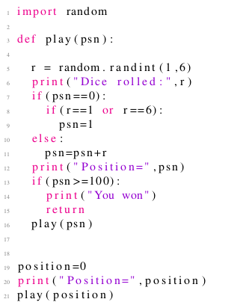

  
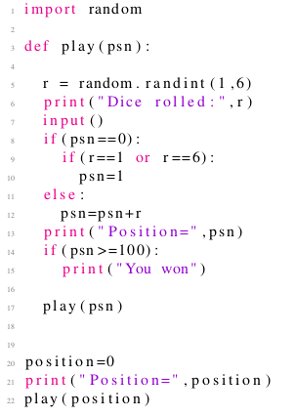

  
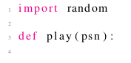  
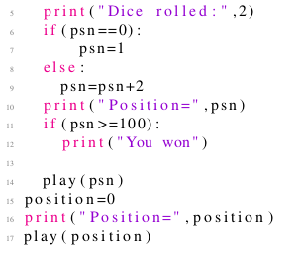

Yes, the answer is correct.  
Score: 1

Accepted Answers:

**

***1 point***

Imagine a single player snakes and ladders game. The code below represents  
  
 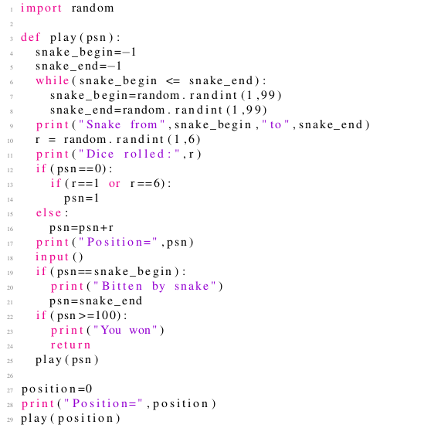

 A snakes and ladders game with one snake whose position remains constant while the player is playing. The position also remains the same during any subsequent plays (i.e. the game board does not change while you sleep and play again the next day).

 A snakes and ladders game with one snake whose position remains constant while the player is playing.However, the position can change during any subsequent plays (i.e. the game board might change while you sleep and play again the next day).

 A snakes and ladders game with one snake where the snake can change its position during the game and also during any subsequent plays (a board game where the snakes keep moving). Further, the snake can bite you any number of times.

 A snakes and ladders game with one snake where the snake can change its position during the game and also during any subsequent plays (a board game where the snake keeps moving). Further, the snake can bite you only ones when you play.

Yes, the answer is correct.  
Score: 1

Accepted Answers:

*A snakes and ladders game with one snake where the snake can change its position during the game and also during any subsequent plays (a board game where the snakes keep moving). Further, the snake can bite you any number of times.*

***1 point***

Imagine a single player snakes and ladders game. The code below represents  
  
 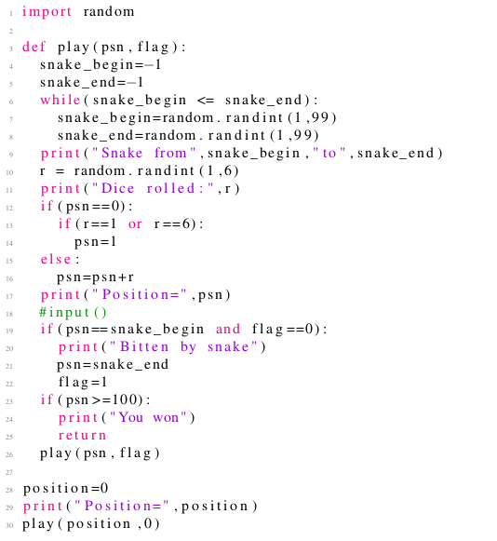

 A snakes and ladders game with one snake whose position remains constant while the player is playing. The position also remains the same during any subsequent plays (i.e. the game board does not change while you sleep and play again the next day).

 A snakes and ladders game with one snake whose position remains constant while the player is playing. However, the position can change during any subsequent plays (i.e. the game board might change while you sleep and play again the next day).

 A snakes and ladders game with one snake where the snake can change its position during the game and also during any subsequent plays (a board game where the snakes keep moving). Further, the snake can bite you any number of times.

 A snakes and ladders game with one snake where the snake can change its position during the game and also during any subsequent plays (a board game where the snake keeps moving). Further, the snake can bite you only ones when you play.

Yes, the answer is correct.  
Score: 1

Accepted Answers:

*A snakes and ladders game with one snake where the snake can change its position during the game and also during any subsequent plays (a board game where the snake keeps moving). Further, the snake can bite you only ones when you play.*

***1 point***

Assuming that the play1() function implements the recursive play of snakes and ladders with the prespecified position of the snake and the  
    ladder as shown in the code below, which of the ambiguities in the options can result in the code? Kindly assume a typical snakes and ladders game.  
  
 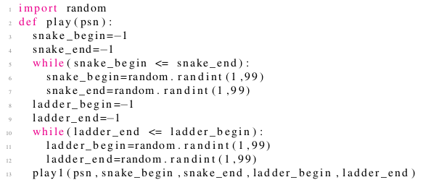

 snake_begin=snake_end

 ladder_begin=ladder_end

 ladder_begin=snake_begin

 ladder_end=snake_end

Yes, the answer is correct.  
Score: 1

Accepted Answers:

*ladder_begin=snake_begin*

***0 points***

What is the output of the following code?  
  
 

 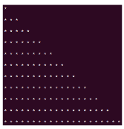

 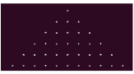

 

 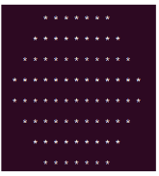

No, the answer is incorrect.  
Score: 0

Accepted Answers:

**

***1 point***

What is the output of the following code?  
  
 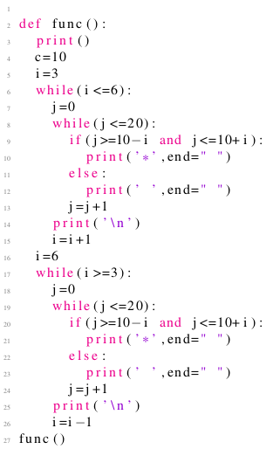

 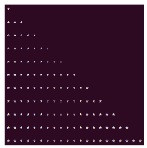

 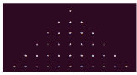

 

 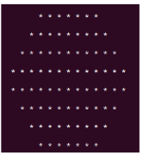

Yes, the answer is correct.  
Score: 1

Accepted Answers:

**